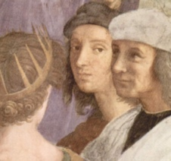

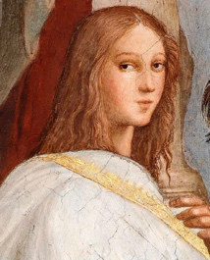  
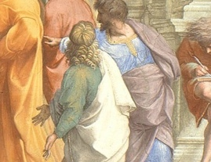  
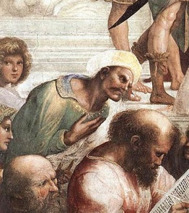  
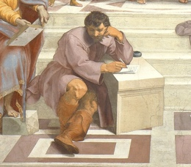  
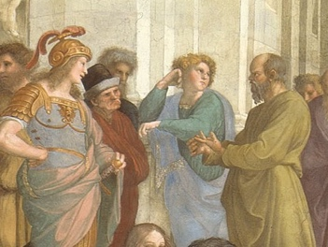  
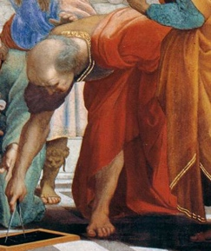

The young man peaking out at the viewer, is none other than Raphael himself.

Hypatia, the first woman documented to have made a contribution to mathematics, astronomy and philosophy.  
  
Alexander the Great, King of Macedonia in the 4th century B.C. and eventual ruler of the land stretching from Greece to India and Egypt.

Pythagoras, an ancient Ionian Greek philosopher, polymath and the eponymous founder of Pythagoreanism.

Heraclitus, a self-taught pioneer of wisdom. He was a melancholy character and did not enjoy the company of others,

Socrates (the rightest), among the crowd surrounding Socrates are his students, including the general Alcibiades and Aeschines of Sphettus.

Euclid, an ancient Greek mathematician active as a geometer and logician.

Plato on the left and Aristotle, his student, on the right. Both figures bound copies of their books in their left hands, while gesturing with their right.